**Anushri Sapate**

**Div A CS(AI)**

**Roll no. 59**

**Lab Assignment 2**

**Advance Linux Command**

**Problems to be solved in the lab:**

1. Select any 5 capitals of states in India and enter them in a file named *capitals1*. Choose 5 more capitals and enter them in a file named *capitals2*. Choose 5 more capitals and enter them in a file named *capitals3*. Concatenate all 3 files and redirect the output to a file named *capitals*.

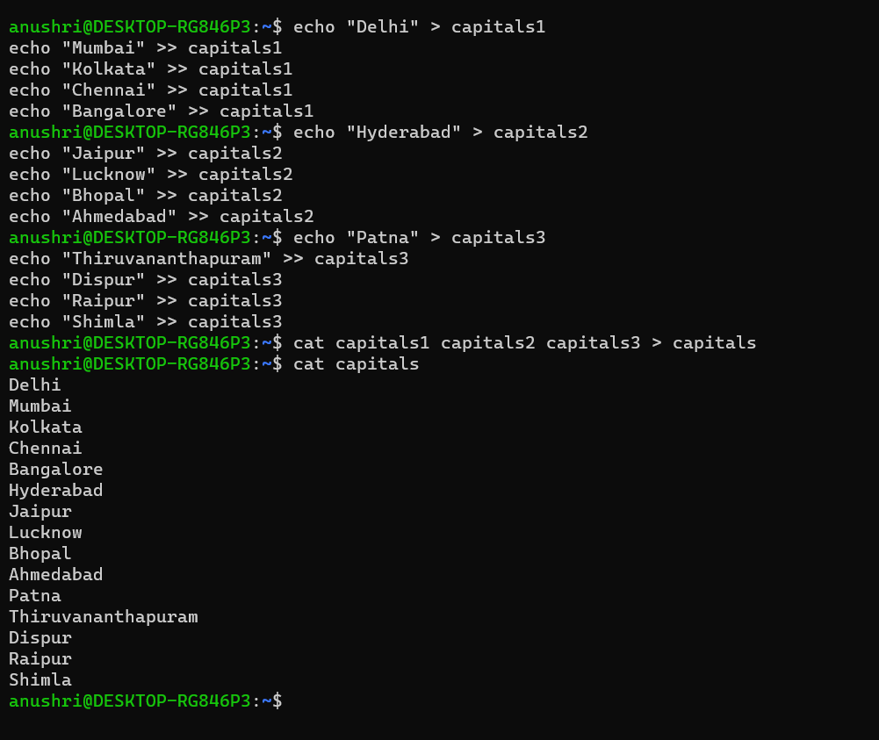

1. Concatenate the file *capitals2* at the end of file *capitals*.

1. Redirect the file *capitals* as an input to the command “wc –l”.

1. Give read and write permissions to all users for the file *capitals*.



1. Give read permissions only to the owner of the file *capitals*. Open the file, make some changes and try to save it. What happens?



1. Create an alias to concatenate the 3 files *capitals1*, *capitals2*, *capitals3* and redirect the output to a file named *capitals*. Activate the alias and make it run.

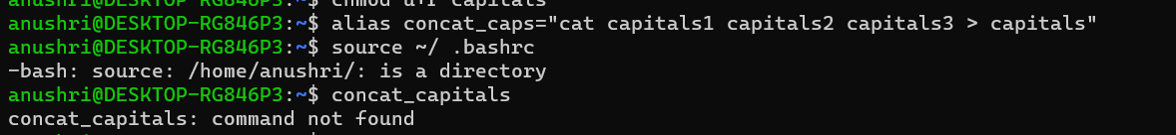

1. What are the environment variables PATH, HOME and TERM set to on your terminal

1. Find out the number of times the string “the” appears in the file *mydate*.



1. Find out the line numbers on which the string “date” exists in *mydate*.

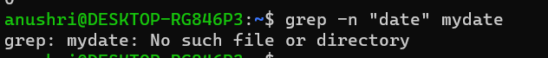

1. Print all lines of *mydate* except those that have the letter “i” in them.



1. Create the file *monotonic* as follows:

^a?b?b?c?…………..x?y?z$

Run the egrep command for *monotonic* against /usr/share/dict/words and search for all 4 letter words.



1. List 5 states in north east India in a file *mystates*. List their corresponding capitals in a file *mycapitals*. Use the *paste* command to join the 2 files.

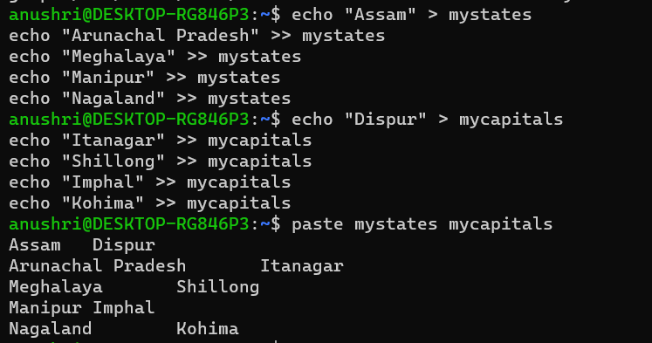

1. Use the *cut* command to print the 1st and 3rd columns of the /etc/passwd file for all students in this class.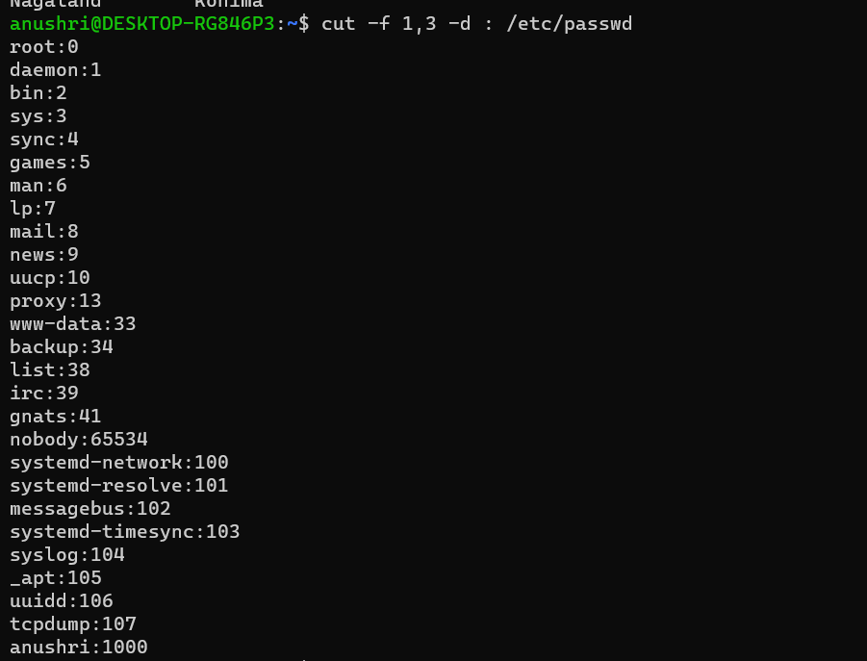
2. Count the number of people logged in and also trap the users in a file using the *tee* command.

